ZOMATO RESTAURANTS ANALYSIS

**INTRODUCTION**

Zomato is an Indian multinational restaurant aggregator and food delivery company. It was founded by Deepinder Goyal and Pankaj Chaddah in 2008 who earlier worked in Bain & Company. The website started as a restaurant-listing-and-recommendation portal. It provides information, menus and user-reviews of restaurants as well as food delivery options from partner restaurants in more than1,000 Indian cities and towns.

The Zomato was formerly known as Foodiebay (2008-10). It’s headquarter is located in Gurugram, Haryana, India. The revenue of the company is around ₹7,079 crore which is around US$890 million in current time. The subsidiaries are Blinkit and Hyperpure. Its official website is [www.zomato.com](http://www.zomato.com).

In 2011, it expanded across India to Delhi NCR, Mumbai, Bangalore, Chennai, Pune, Ahmedabad and Hyderabad. In 2012, it expanded operations internationally in several countries, including the United Arab Emirates, Sri Lanka, Qatar, the United Kingdom, the Philippines, and South Africa. In 2013, It expanded to New Zealand, Turkey, Brazil and Indonesia with websites and apps available in Turkish, Portuguese, Indonesian, and English. In April 2014, it was launched in Portugal, which was followed by launches in Canada, Lebanon, Ireland in 2015. In January 2015, Zomato acquired Seattle-based restaurant discovery portal Urbanspoon, which led to the firm’s entry into the United States and Australia. In February 2017, the firm announced plans to launch Zomato Infrastructure Services, a cloud kitchen infrastructure service to help partner restaurants expand their presence without incurring any fixed costs. Later that year, it introduced a paid membership program called Zomato Gold using which subscribers could get offers and discounts on dining and food delivery at

Zomato’s partner restaurants.

In December 2018, Zomato launched its annual multi-city food and entertainment carnival called Zomaland. In March 2019, Zomato sold its UAE food delivery business to Talabat.In June 2023, Zomato launched a feature that enabled users to build carts from up to four restaurants and place the orders together. In October 2023, the company started offering hyperlocal package delivery service on a separate app called Xtreme.

**FUN FACTS ABOUT ZOMATO**

* The food delivery app operates in 24 countries with10,000 cities globally.
* The most ordered dish on Zomato is “Biryani”, in the pandemic 2020, 44 lakhs+ orders were placed for Biryani.
* During the Pandemic in 2020, Zomato delivered amount 22 Biryanis every minute.
* On average Zomato gets 12.5 lakh orders daily.
* The most expensive order placed on Zomato costs nearly Rs. 2 Lakh.
* Zomato IPO is one of the biggest IPO by the startup in India.

**HOW ZOMATO WORKS**

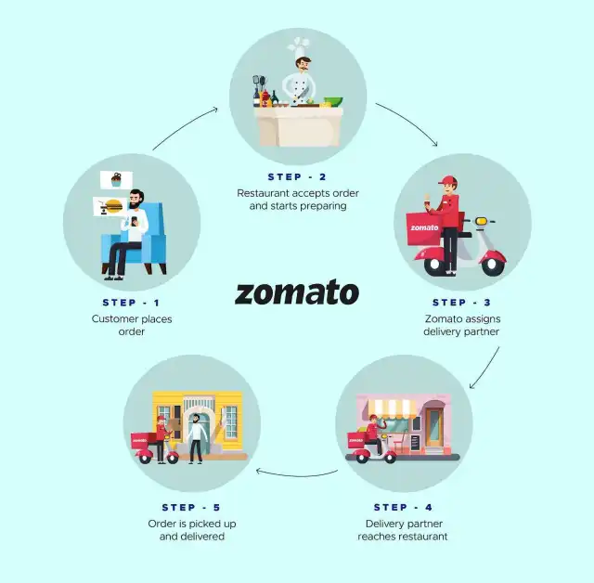

As the above picture shown this is how the Zomato works. The processing of food delivery begins from the customer’s place where he/she orders food from its device. Later on, its forwarded to restaurant where they accept the order and starts preparing. Meanwhile the order is being prepared the Zomato assigns the delivery partner for the ongoing order process. Then in the last part of the process the Delivery partner pickups the food from the restaurant and drops the package to the customer within the allotted time slots.

**INSIGHTS OF PROJECT ANALYSIS**

The basic objective of the project is to analyze the data to get an output of how a company can increase its market in the already serving area and can open new restaurants in the new area or an existing area. The data we received is from the Zomato company itself.

The tools which have been used to determine the following analysis are VLOOKUP, If functions, AVERAGE, SUM, PIVOTS, and CHARTS.

OBJECTIVE QUESTIONS OF ANALYSIS

1.What is the total no. of tables present in the data?

The raw data contains about two table which was given in two separate worksheets named raw data and country description.

2.What is the total no. of attributes present in the data?

The attributes here are refer to the column names of the provided tables. There are around 20 attributes present in the raw data. Thus, for further analysis total 3 more attributes were added in the raw data using different formulas. So, in total there are 23 attributes in data.

3. How many categorical columns are there in the data?

The categorical columns refer to the column that consists of data that is consist of categorical information. In the provided data there are about 8 categorical data **which includes Country name, Cuisine, Currencies, etc.**

**4.** The data consists of some inconsistent and missing values so ensure that the data used for further analysis is cleaned.

There were some missing values in the cuisine column which I replaced it manually with the highest number of cuisine in the world category. Then there were some data issue in the city name as Sao Paulo and Istanbul was written incorrectly as Sí£o Paulo and UAstanbul respectively by find and replace function in MS Excel.

5. Using the LookUp functions, fill up the countries in the original data using the country code.

With the help of given country code in the raw data, A new column named country name was added by using VLOOKUP function in the raw data from the country description worksheet.

6. Create a table to represent the number of restaurants opened in each country.

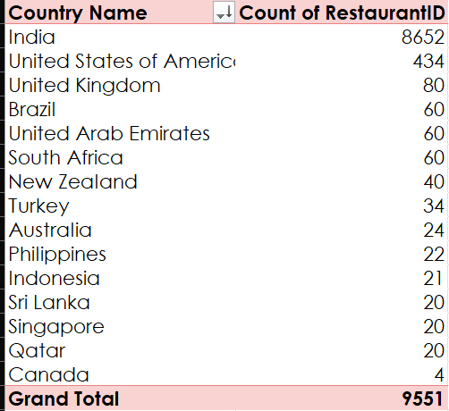

According to the data, it can be said that India has the most number of restaurants opened by Zomato up to the present 2018 that is about 8652. Followed by the United States of America that is about 434 restuarants. While the lowest number of restaurants that were opened were in Canada that is only 4.

7. Also, the management wants to look at the number of restaurants opened each year, so provide them with something here.

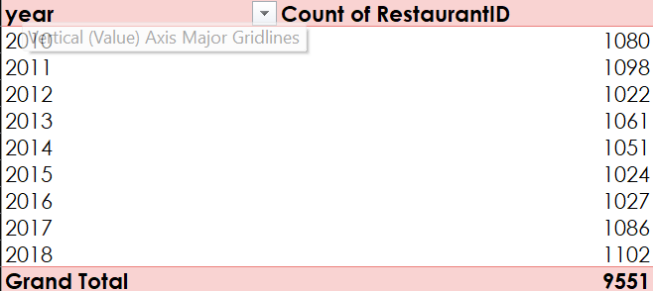

From the above given picture, it can be seen that maximum number of restaurants were opened in the year 2018, which is followed by the year 2011. While there were least numbers of opening in the year 2012.

8. What is the total number of restaurants in India in the price range of 4?

There are about 388 restaurants in India that has the price range of 4, which was find out by the given formula

9. What is the average number of voters for the restaurants in each country according to the data?

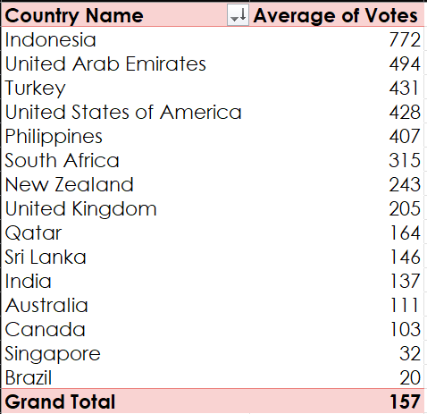

The highest number of voters were found out in the Indonesia which is followed by United Arab Emirates. While Brazil has the lowest average number of voters as compared to all the countries served by Zomato

10. Calculate the average rating for all the restaurants that have price_range < 4 and provide online delivery. Use only the “IF” function, Logical Operators, and Aggregation functions to solve this problem.

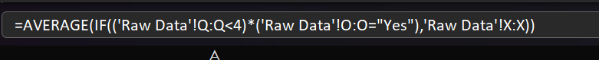

The average rating for all the restaurants that have price_range < 4 and provide online delivery is 3.18.

11.Using Conditional formatting highlight the rows of restaurants that are located in the countries or cities that you’ve suggested to the management for opening new restaurants.

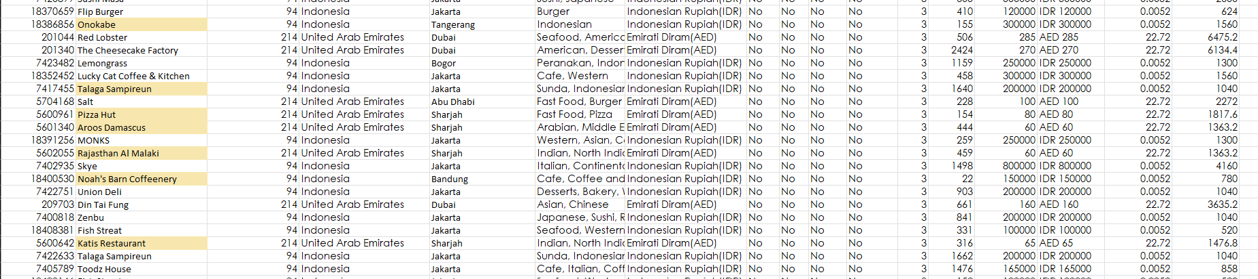

Above are the highlighted restaurants that are present in the cities I have mentioned to open the restaurant in Indonesia and United Arab Emirates.

12. Create a new customized price column that consists of the abbreviation/symbol of the currency along with the Average_cost_for_two value. [Use string operations to do this task]



Above given is the formula I used to find the create a new customized price column that consists of the abbreviation/symbol of the currency along with the Average_cost_for_two value.

13. How can you create an array formula in Excel or Google Sheets to count the number of restaurants listed that do not offer online delivery, are in the lowest price range, and have an average cost for two people less than or equal to 250 Indian Rupees?



The total number of restaurants that do not offer online delivery , are in the lowest price range, and have an average cost for two people less than to 250 Indian Rupees is 4437.

**SUBJECTIVE QUESTIONS**

1. Suggest a few countries where the team can open newer restaurants with lesser competition. Which visualization/technique will you use here to justify the suggestions?

The few countries I would suggest to open newer restaurants with lesser competition are Indonesia and United Arab Emirates. Because both the countries have maximum number of ratings as compared to all other nations as their average are something near to 4.30 and 4.23 respectively with 16214 and 29611 votes respectively.

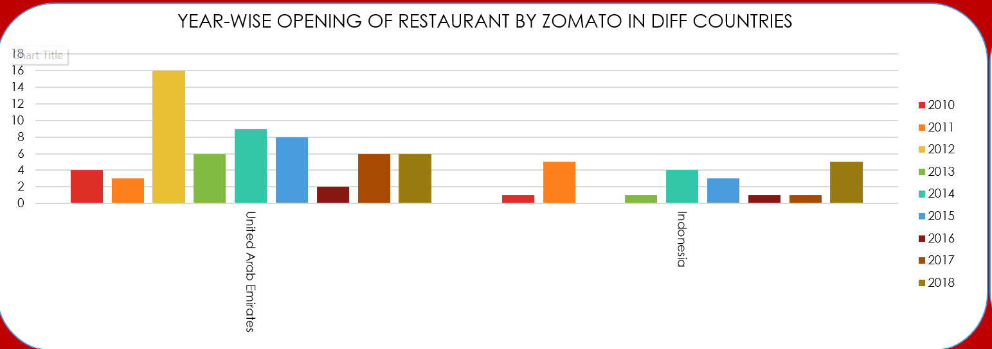

2. Come up with the names of States and cities in the suggested countries suitable for opening restaurants.

The cities I would recommend to open the restaurants in the suggested countries area as follows:

INDONESIA: In total there are 4 cities that are currently having restaurants that are operated by Zomato that are Bogor, Tangerang, Jakarta and Bandung. The maximum number of restaurants are mostly concentrated in Jakarta. So, opening a new restaurant I would recommend would be the Tangerang and Bandung, as the rating around these cities is high with a smaller number of choices so would recommend to open more new restaurants.

UNITED ARAB EMIRATES: Likewise, Indonesia there only 3 cities that are served by Zomato in UAE that are Sharjah, Abu Dhabi and Dubai. The distributions of the restaurants in these 3 cities are even as each cities have 20 restaurants each. Still I would recommend the city in which restaurant should be open is Sharjah as there are no restaurants that provide online delivery and table booking.

3. According to the countries you suggested, what is the current quality regarding ratings for restaurants that are open there?

The current quality regarding ratings for restaurants that are open there is 4.30 and 4.23 in Indonesia and UAE respectively. Though very a smaller number of restaurants have extra facilities that are provided by the restaurant. As the demand of food is high over there, the new restaurants will have great response.

|  |  |  |
| --- | --- | --- |
| **City** | **Count of RestaurantID** | **Average of Rating** |
| Abu Dhabi | 20 | 4.3 |
| Dubai | 20 | 4.37 |
| Sharjah | 20 | 4.03 |

|  |  |  |
| --- | --- | --- |
| **City** | **Count of RestaurantID** | **Average of Rating** |
| Bandung | 1 | 4.2 |
| Bogor | 2 | 3.85 |
| Jakarta | 16 | 4.35625 |
| Tangerang | 2 | 4.3 |

4. Also, what is the current expenditure on food in the suggested countries, so we can keep our financial expenditure in control?

|  |  |
| --- | --- |
| **City** | **Average of Average_Cost_for_two** |
| Bandung | 150000.00 IDR |
| Bogor | 160000.00 IDR |
| Jakarta | 308437.50 IDR |
| Tangerang | 250000.00 IDR |
| **Grand Total** | **281190.48 IDR** |

The total expenditure of the suggested cities are as follows: In Indonesia the average cost of two people is around 281190.28 IDR. The price range of the two is from about 70000 IDR to maximum of 800000 IDR. Same as Indonesia, in United Arab Emirates the average cost of two people is around 166.42 AED. While its price ranges from around 50 AED to maximum of 250 AED.

|  |  |
| --- | --- |
| **City** | **Average of Average_Cost_for_two** |
| Abu Dhabi | 182.00 AED |
| Dubai | 211.75 AED |
| Sharjah | 105.50 AED |
| **Grand Total** | **166.42 AED** |

5. Come up with the names of restaurants from the recommended states that are our biggest competitors and also those that are rated in the lower brackets, i.e. 1-2 or 2-3.

The Talaga Sampireun and Sushi Masa can be our biggest competition as they have the highest ratings among all the restaurants available there as its rating is around 4.9 and 4.6 respectively despite having no extra facilities provided by them. These restaurants are ranging in 2-3 price range. While in UAE, the AB’s Absolute Barbeque and Punjab Grill can be a tough competition as its rating ranges from 4.8-4.9 and 4.9 respectively. While both the restaurants provide online table booking options. The price range of both the restaurant is in 3 and 4 respectively.

6. Which cuisines should we focus on in the newer restaurants to get better feedback? Does the choice of cuisines affect the restaurant ratings?

The cuisine plays a big role in the ratings of the restaurants. In UAE, the Indian cuisine is more popular than the other cuisine which is mostly North Indian or Rajasthani cuisine. Which is followed by American or fast-food cuisines. From the table it can be seen that there are total 16 restaurants serving north Indian cuisine ands its average rating ranges from 4.6-3.9. Which show its relation between cuisine and rating.

FOR U.A.E.:

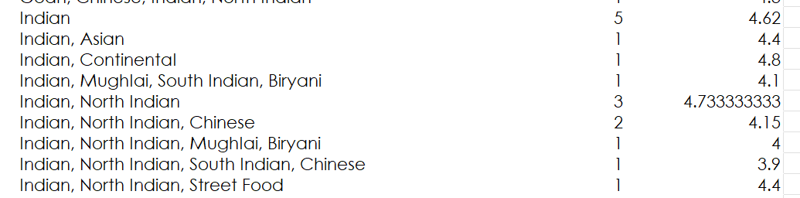

FOR INDONESIA:

While in the Indonesia the most popular cuisines are Sunda, Indonesian and Sushi. The maximum number of restaurants which serves Sunda, Indonesian and Sushi. And these were the top most rated among the total cuisine served in the areas.

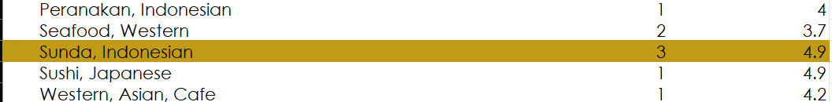

7. According to our current data, should we go for online delivery and table booking? Does that affect the customer’s ratings?

According to our current data, we should definitely go with online delivery and table booking features. As this affects the rating of the restaurants, it can be seen that the restaurants that provide these facilities has more ratings as compared to the restaurants that don’t provide such facilities.

|  |  |
| --- | --- |
| **Has_Online_delivery** | **Average of Rating** |
| No | 2.754309859 |
| Yes | 3.288004896 |

|  |  |
| --- | --- |
| **Has_Table_booking** | **Average of Rating** |
| No | 2.809686644 |
| Yes | 3.482556131 |

**8.** Should the team keep the rate of cuisines higher? Will that affect the feedback? According to our data are the rates of cuisines and ratings, correlated?

No, the rate of cuisines cannot be increased because no correlation can be found regarding the rating and cuisine in the given data as its highly dynamic, as we can see same cuisine have different price range. So, in my opinion the price should be increased according to the facilities and other criteria. And it can also be seen that same cuisine having low price range have better rating.

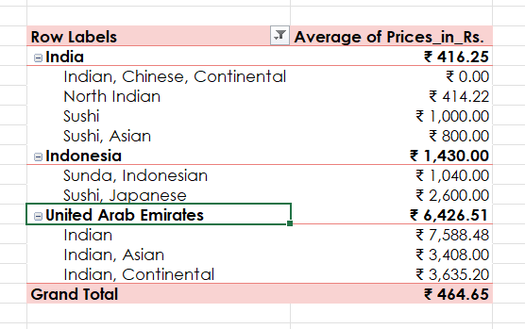

9. What is the distribution of the number of restaurants of different price ranges in all the countries?

The distribution of the number of restaurants of different price ranges in all countries is highly variated. As the number with price range 1 has the maximum number of restaurants that is 4444, while there are only 586 restaurants in the price range of 4.

|  |  |
| --- | --- |
| **Price_range** | **Count of RestaurantID** |
| 1 | 4444 |
| 2 | 3113 |
| 3 | 1408 |
| 4 | 586 |

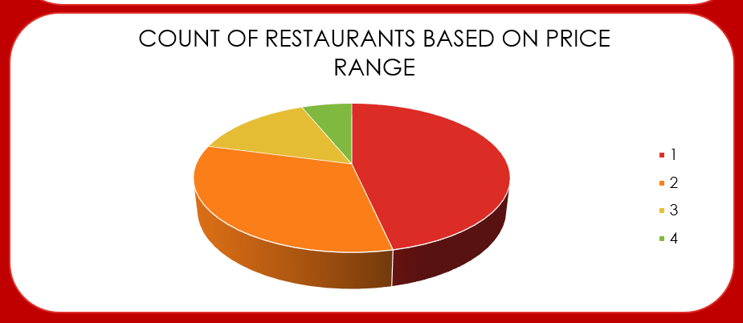

10. Explain your approach in brief for suggesting countries/cities in order to open new restaurants, if the objective and subjective questions would have been given to assist you. **[you have to give bullet pointers in order to answer this question]**

1. **The approach I used to provide the suggestions for opening a new restaurant is the number of people involved in rating the food.**
2. **The second thing I kept in my mind was the country with highest rating with respect to the number of votes, which shows that there is a greater number of peoples as compared to restaurants.**
3. **As mentioned above the number of people is more than the number of restaurants thus adding a new restaurant will draw more people to new restaurant along with the old customer if the food quality is maintained.**
4. **As also seen in the suggested countries or cities it can be seen that most of the restaurants didn’t have extra facilities thus opening a new restaurant with these facilities will draw more people which will lead to more customers**.
5. **It can also be seen that price range of food here in these countries is very high thus it will lead to have the good rate compared to other**.

Thus, this was my observation with respect to the provided data, I believe a new restaurant in the Indonesia and UAE will help in improving the current situation without applying high infrastructure.

**Dashboard**

